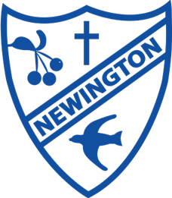  Welcoming, Flourishing, Generous, Forgiving | Newington CEP School  Newsletter  Issue 6 – March 2023  Realising the God-Given Potential in Everyone
@NewingtonCEP | www.newington.kent.sch.uk

Message from Mr. Krafft & Mrs. Deevoy
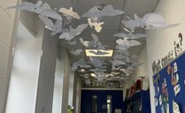It is the end of the Spring Term! It has been a busy time in school but there have been so many highlights. One in particular is the display of Peace Doves that is currently being installed in our gallery. This has been part of our Lent Project and every class in the school has contributed.
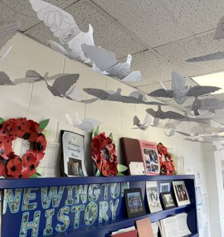
This is a humble tribute to the artwork by Peter Walker which is currently on display at Rochester Cathedral.
We are looking forward to you all seeing it when it has been completed.
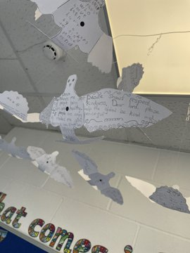
Some of you would have already seen it being put together when you attended Parents Evening. Thank you to everyone who attended. It was great seeing everyone and we know the teachers enjoyed the experience. We will be holding open classrooms next term so will see you all again then.

Thank you again for all of your support with improving our attendance. We must continue to make this a priority but there have been improvements and We hope this continues in the summer term.

Have a great Easter break everyone!
Mr Krafft and Mrs Deevoy
A message from the School Council
Dear families,
In our school council meeting we have been thinking about how we can improve punctuality. When someone is late it disrupts our learning. Here are some of our ideas you can try at home:
- Make sure everyone knows what time school starts.
- Leave home in good time.
- Allow a little time for things to go wrong!
- Set alarms.
- Use phones/SATNAV before setting out to check for traffic jams.
- Walk, bike or scooter rather than taking the car- it can actually be quicker!
- Walk together with friends and help each other be on time.
- Use the school morning club.
Even if we do everything in our list, there are times when we still might be late. If that happens please remember to say “Sorry I am late”.

Thank you for reading our message.
Newington School Council

PFA Updates
A massive thank you to our PFA who have organised a fun Easter activity and distributed chocolate eggs to all of the children - what a great way to start the Easter holidays! We are still looking for new members to join the PFA and help raise money and arrange memorable events for the children. If you think you can help out then please contact the school office.
Online Safety Week
Thank you to everyone who submitted a suggestion for Online Safety week. The staff have been working hard collating all the feedback and designing a week of learning that will meet the needs of our families. Everyone can expect the children to complete work that will support the whole family in living in an increasingly technological world. We will also be providing tips and advice on Ping throughout the week, so please ensure you can access the app.

Clubs
Below is a list of that we will offering for terms 5 and 6. If you have any ideas for future clubs, please let us know.

Monday
Football & Multi Sports – KS2 | Mr Lloyd & Mrs Jones
Computing Club – KS2 | Miss Hendry
Tuesday
Multi Sports – KS1 | Mrs Barton
Wednesday
Tennis – Yrs 1, 2, 3 & 4 | Danny Wynn
Thursday
Model Railway Club | Mr Krafft and Mr Saunders
Gardening Club – Whole School | Mrs O’ Connor
Printing Art Club – Whole School | Miss Guthrie
Harry Potter Club – KS2 | Miss Blackbourn & Mr Lloyd
Family Café – Whole School | Mrs Holton
Friday (Alternate Weeks)
Go Kart – Yr 6 | Mrs Calder

We are currently looking into running a KS1 football club – More info to follow

Dates for Your Diary
Below is an outline of some of the things we have planned. We hope to add to this and will send messages through School Ping to individual classes.
Please ensure you check School Ping to stay up to date with the latest events going on in your child’s class.

INSET DAYS – Pupils do not Attend
Inset Day 4 – Friday 23 June 2023
Inset Day 5 – Monday 3 July 2023

Term 4
March
- Friday 31st March – PFA Chocolate Egg Hunt / End of Term
April
Term 5
- Monday 17th April – Start of Term 5
- Monday 17th April – Friday 21st April – Online Safety Week
- Thursday 20th April – Southern Water Assembly
- Monday 24th April – Earth Day
May
- Wednesday 3rd May – Family Trust Assembly
- Monday 8th May - Bank holiday for the coronation of King Charles III
- Tuesday 9th May – KS2 SATs Week
- Friday 12th May – Coronation Tea Party
- Thursday 18th May – Class Photos
- Monday 22nd May – Friday 26th May – Charity Week
- Friday 26th May – Pentecost Service – 10:45am – Newington Church
- Friday 26th May – End of Term 5
Term 6
June
- Monday 5th June – Start of Term 6
- Monday 12th June – Start of Phonics Screen Checks
- Wednesday 14th June – Friday 16th June – School Journey
- Tuesday 20th June – Sports Day (PM)
- Friday 23rd June – INSET Day
- Monday 26th June – French Experience Day
- Thursday 29th June – Reserve Sports Day
July
- Monday 3rd July – INSET Day
- Friday 7th July – First Aid Training for Year 6
- Friday 21st July – End of Term 6

